Module 3 & 4 Assignment

Tools you can use for below questions: VirtualBox with Linux VMs, GNS3, Cisco Packet Tracer, Wireshark etc.
• Simulate a small network with switches and multiple devices. Use ping to generate traffic and observe the MAC address table of the switch. Capture packets using Wireshark to analyze Ethernet frames and MAC addressing.
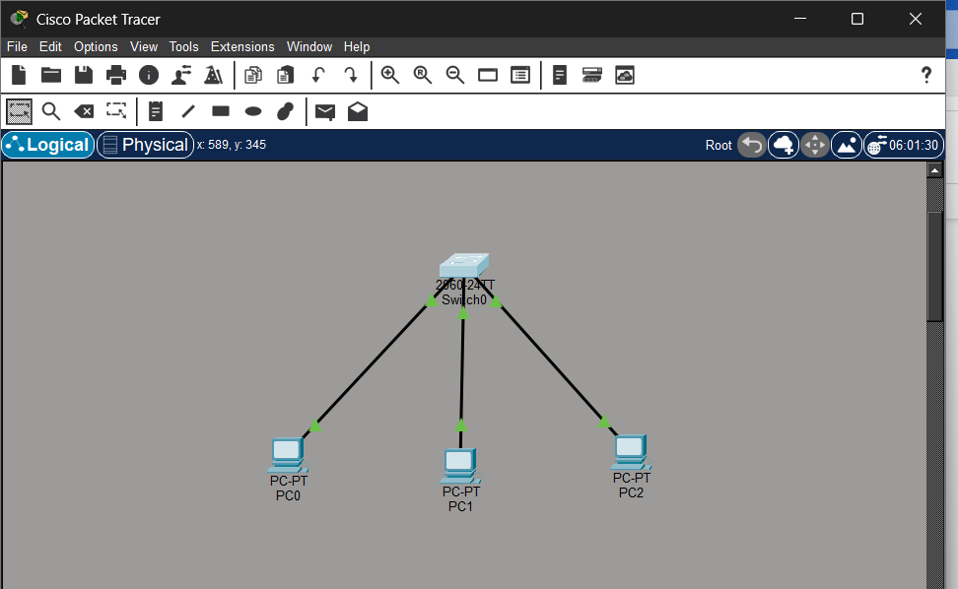

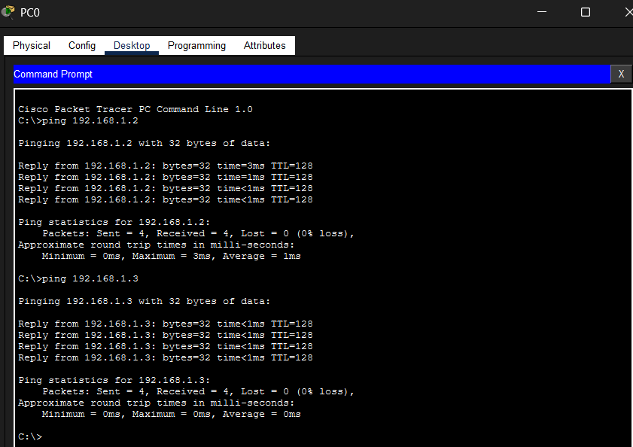

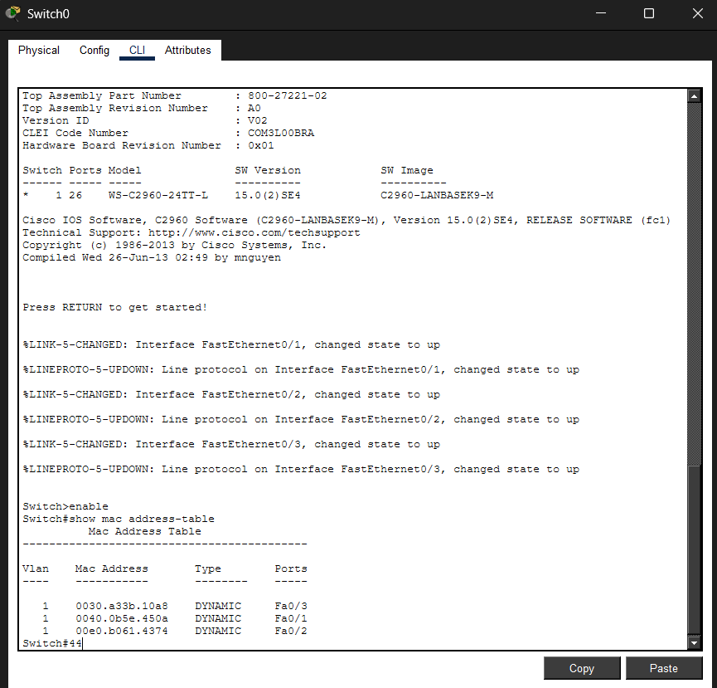

✔ The switch initially had an empty MAC table.
✔ After sending ping packets, the switch learned the MAC addresses.
✔ The MAC addresses were stored dynamically in the MAC address table.
✔ The table maps MAC address → switch port.
• Capture and analyze Ethernet frames using Wireshark. Inspect the structure of the frame, including destination and source MAC addresses, Ethertype, payload, and FCS. Use GNS3 or Packet Tracer to simulate network traffic.
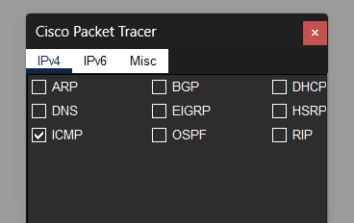
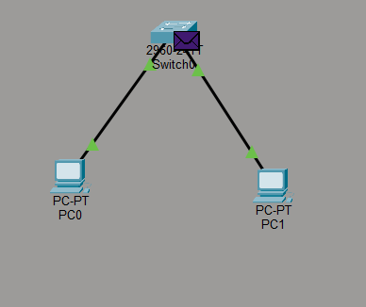

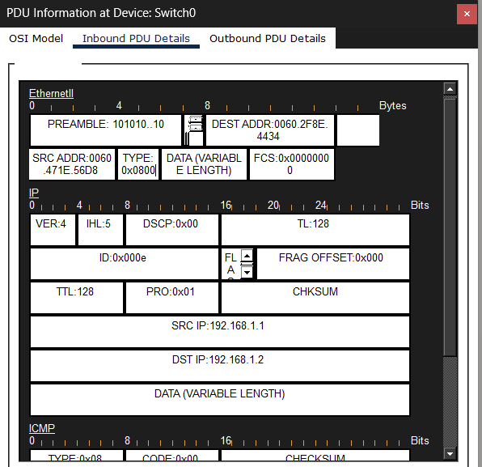
Ethernet frames were analyzed using the simulation mode in Cisco Packet Tracer. The frame contained source and destination MAC addresses which identify the sender and receiver devices in the local network. The EtherType field indicated that the frame carried an IPv4 packet. The payload of the Ethernet frame contained an IP packet with source IP address 192.168.1.1 and destination IP address 192.168.1.2. The IP packet further carried an ICMP echo request generated by the ping command. The Ethernet frame also includes a Frame Check Sequence used for error detection during transmission.

• Configure static IP addresses, modify MAC addresses, and verify network connectivity using ping and ifconfig commands.
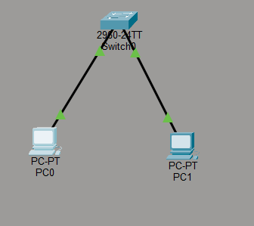
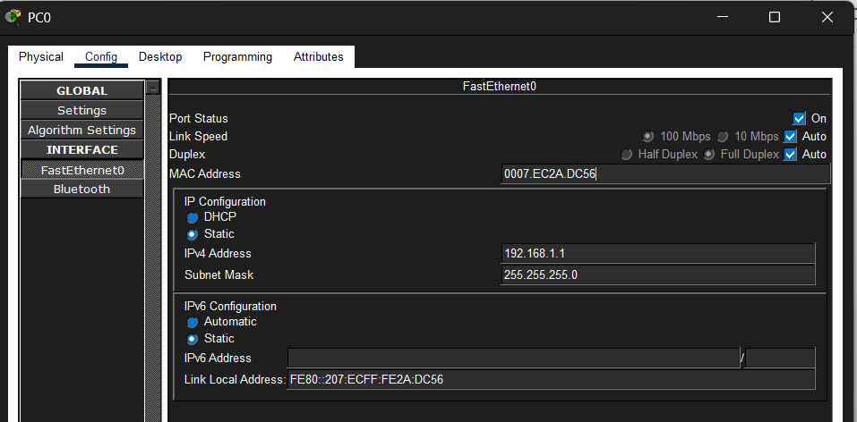

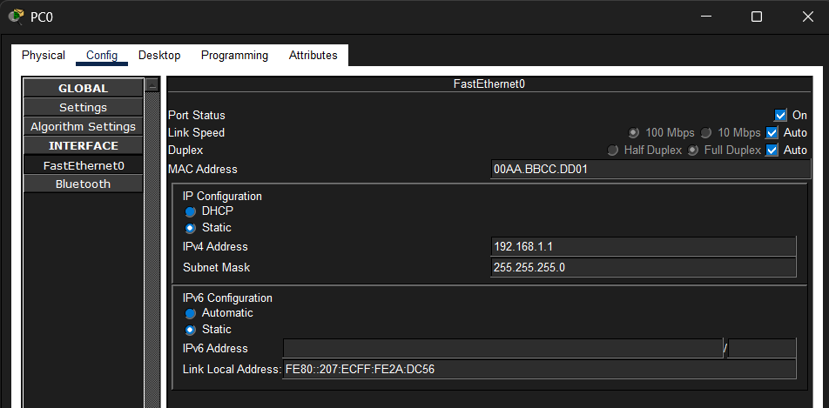

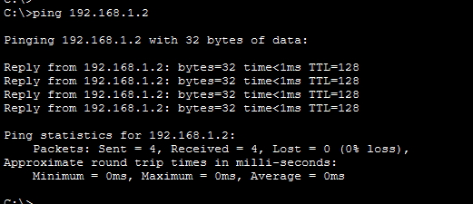

When the ping command is executed:
- PC0 sends an ICMP Echo Request packet.
- The packet is encapsulated in an Ethernet frame.
- The switch reads the destination MAC address and forwards the frame to PC1.
- PC1 receives the request and sends an ICMP Echo Reply.
- PC0 receives the reply confirming connectivity.
Static IP addresses were configured on the PCs in Cisco Packet Tracer using the IP configuration settings. The IP configuration was verified using the ipconfig command. The MAC address of the network interface was viewed and modified through the FastEthernet configuration settings. Network connectivity between the devices was tested using the ping command. Successful ping replies confirmed that communication between the devices in the local network was established.
• Troubleshoot Ethernet Communication with ping and traceroute → Using Cisco Packet Tracer:
Use traceroute to identify where the packets are being dropped if the ping fails.
Test Communication Using Ping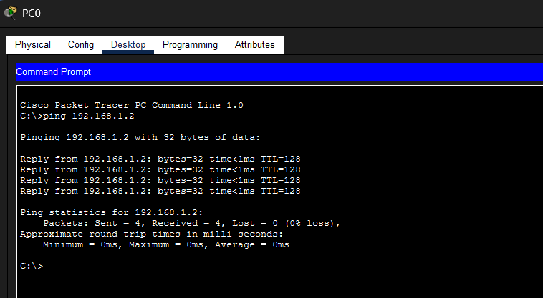

Simulate a Network Problem:
Change the IP address of PC1 to a different network.
IP Address : 192.168.2.2
Subnet Mask : 255.255.255.0
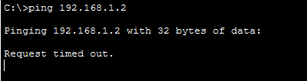

Use Traceroute to Diagnose the Problem:
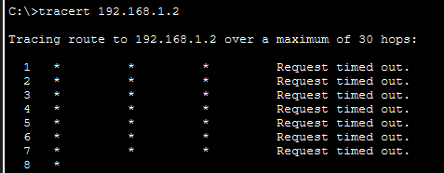
Correct the IP address of PC1:
IP Address : 192.168.1.2
Subnet Mask : 255.255.255.0
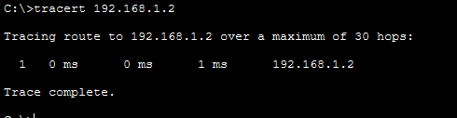
Ethernet communication between two PCs connected through a switch was tested using ping and traceroute commands in Cisco Packet Tracer. Ping was used to verify connectivity between the devices. When an incorrect IP address was configured, the ping request failed indicating a network issue. Traceroute was used to analyze the packet path and identify where the communication stopped. After correcting the IP configuration, the ping command successfully verified communication between the devices.

• Create a simple LAN setup with two Linux machines connected via a switch.

Network Setup
The LAN consists of the following devices:
- Two Linux machines (represented as PCs in Packet Tracer)
- One switch → Cisco Catalyst 2960 Switch
The devices are connected using Ethernet copper straight-through cables.
Topology:
Linux Machine 1 -------- Switch -------- Linux Machine 2

The switch acts as a central device that forwards Ethernet frames between the two machines.

Configure Static IP Addresses
Each Linux machine must be assigned a static IP address in the same network.
Example configuration:
Linux Machine 1
IP Address : 192.168.1.1
Subnet Mask : 255.255.255.0
Linux Machine 2
IP Address : 192.168.1.2
Subnet Mask : 255.255.255.0
These addresses belong to the same subnet 192.168.1.0/24, allowing communication between the machines.

Verify Network Configuration
The network interface configuration can be verified using the command:
ifconfig
Example output:
eth0: flags=4163
inet 192.168.1.1
netmask 255.255.255.0
This confirms that the network interface has been assigned the correct IP address.

Test Connectivity Using Ping
To verify communication between the two machines, the ping command is used.
On Linux Machine 1 run:
ping 192.168.1.2
Example result:
64 bytes from 192.168.1.2: icmp_seq=1 ttl=64 time=0.5 ms
64 bytes from 192.168.1.2: icmp_seq=2 ttl=64 time=0.4 ms
The replies confirm that both machines can communicate through the switch.

Working of the LAN
When the ping command is executed:
- The first machine sends an ICMP Echo Request packet.
- The packet is encapsulated into an Ethernet frame.
- The switch reads the destination MAC address.
- The switch forwards the frame to the correct port connected to the second machine.
- The second machine replies with an ICMP Echo Reply.
This confirms successful Ethernet communication within the LAN.

Observation
A simple LAN was created with two Linux machines connected through a switch. Static IP addresses were configured on both machines to place them in the same subnet. The network configuration was verified using the ifconfig command. Connectivity between the machines was tested using the ping command, and successful replies confirmed that communication over the Ethernet network was established.
• Ping from one machine to the other. If it fails, use ifconfig to ensure the IP addresses are configured correctly.
The objective of this task is to test communication between two machines in a Local Area Network and troubleshoot the problem if communication fails.
Network Setup
A simple LAN is created with:
- Two Linux machines (represented as PCs in Packet Tracer)
- One switch → Cisco Catalyst 2960 Switch
Topology:
Machine 1 -------- Switch -------- Machine 2

Both machines are connected using Ethernet copper straight-through cables.

Configure IP Addresses
Assign static IP addresses to both machines.
Machine 1
IP Address : 192.168.1.1
Subnet Mask : 255.255.255.0
Machine 2
IP Address : 192.168.1.2
Subnet Mask : 255.255.255.0
Both devices are now in the same subnet.

Test Communication Using Ping
Ping is used to check whether one machine can reach the other.
On Machine 1, open terminal (or Command Prompt in Packet Tracer) and run:
ping 192.168.1.2
Example output:
Reply from 192.168.1.2
Reply from 192.168.1.2
Reply from 192.168.1.2
This means the communication between the machines is successful.

When Ping Fails
If ping fails, you may see:
Request timed out
or
Destination host unreachable
This indicates a configuration problem.

Check IP Address Using ifconfig
To troubleshoot the issue in Linux, the ifconfig command is used to verify the network interface configuration.
Run:
ifconfig
Example output:
eth0: flags=4163
inet 192.168.1.1
netmask 255.255.255.0
Check the following:
- Correct IP address
- Correct subnet mask
- Interface eth0 is active
If the IP address is incorrect, reconfigure it.
Correct the Configuration
Ensure both machines have:
Machine 1 : 192.168.1.1
Machine 2 : 192.168.1.2
Subnet Mask : 255.255.255.0
Now run ping again:
ping 192.168.1.2
The reply confirms that the communication problem has been resolved.

Observation
Two machines connected through a switch were tested for connectivity using the ping command. When the ping request failed, the network configuration was checked using the ifconfig command to verify the assigned IP addresses. After correcting the IP configuration, the ping command successfully confirmed communication between the machines.
• Research the Linux kernel's handling of Ethernet devices and network interfaces. Write a short report on how the Linux kernel supports Ethernet communication (referencing kernel.org documentation).
Configure a LAN Interface using ip command:
harishma@Harishma:~$ sudo ip addr add 192.168.1.10/24 dev eth0
[sudo] password for harishma:
harishma@Harishma:~$
Activate Interface
harishma@Harishma:~$ sudo ip link set eth0 up
Verify the IP Address
harishma@Harishma:~$ ip addr show eth0
2: eth0: <BROADCAST,MULTICAST,UP,LOWER_UP> mtu 1500 qdisc mq state UP group default qlen 1000
link/ether 00:15:5d:6f:44:13 brd ff:ff:ff:ff:ff:ff
inet 172.19.82.156/20 brd 172.19.95.255 scope global eth0
valid_lft forever preferred_lft forever
inet 192.168.1.10/24 scope global eth0
valid_lft forever preferred_lft forever
inet6 fe80::215:5dff:fe6f:4413/64 scope link
valid_lft forever preferred_lft forever

View MAC Address
harishma@Harishma:~$ ip link show eth0
2: eth0: <BROADCAST,MULTICAST,UP,LOWER_UP> mtu 1500 qdisc mq state UP mode DEFAULT group default qlen 1000
link/ether 00:15:5d:6f:44:13 brd ff:ff:ff:ff:ff:ff
Check MAC Table (Linux Switch Concept)
harishma@Harishma:~$ bridge fdb show
33:33:00:00:00:01 dev eth0 self permanent
01:00:5e:00:00:01 dev eth0 self permanent
33:33:ff:6f:44:13 dev eth0 self permanent
• Describe how you would configure a basic LAN interface using the ip command in Linux (kernel.org).
harishma@Harishma:~$ ip link
1: lo: <LOOPBACK,UP,LOWER_UP> mtu 65536 qdisc noqueue state UNKNOWN mode DEFAULT group default qlen 1000
link/loopback 00:00:00:00:00:00 brd 00:00:00:00:00:00
2: eth0: <BROADCAST,MULTICAST,UP,LOWER_UP> mtu 1500 qdisc mq state UP mode DEFAULT group default qlen 1000
link/ether 00:15:5d:6f:44:13 brd ff:ff:ff:ff:ff:ff
harishma@Harishma:~$ sudo ip addr add 192.168.1.10/24 dev eth0
[sudo] password for harishma:
harishma@Harishma:~$
harishma@Harishma:~$ sudo ip link set eth0 up
harishma@Harishma:~$ ip addr show eth0
harishma@Harishma:~$ ip addr show
1: lo: <LOOPBACK,UP,LOWER_UP> mtu 65536 qdisc noqueue state UNKNOWN group default qlen 1000
link/loopback 00:00:00:00:00:00 brd 00:00:00:00:00:00
inet 127.0.0.1/8 scope host lo
valid_lft forever preferred_lft forever
inet 10.255.255.254/32 brd 10.255.255.254 scope global lo
valid_lft forever preferred_lft forever
inet6 ::1/128 scope host
valid_lft forever preferred_lft forever
2: eth0: <BROADCAST,MULTICAST,UP,LOWER_UP> mtu 1500 qdisc mq state UP group default qlen 1000
link/ether 00:15:5d:6f:44:13 brd ff:ff:ff:ff:ff:ff
inet 172.19.82.156/20 brd 172.19.95.255 scope global eth0
valid_lft forever preferred_lft forever
inet 192.168.1.10/24 scope global eth0
valid_lft forever preferred_lft forever
inet6 fe80::215:5dff:fe6f:4413/64 scope link
valid_lft forever preferred_lft forever
• Use Linux to view the MAC address table of a switch (if using a Linux-based network switch). Use the bridge or ip link commands to inspect the MAC table and demonstrate a basic switch's operation.

Viewing Network Interfaces
First, the available network interfaces in the Linux system can be viewed using the following command:
ip link
Example output:
2: eth0: <BROADCAST,MULTICAST,UP>
link/ether 00:15:5d:6f:44:13
The link/ether field shows the MAC address of the network interface.

Viewing the MAC Address Table Using the Bridge Command
If the Linux system is functioning as a bridge or software switch, the MAC address table can be viewed using the following command:
bridge fdb show
Example output:
00:15:5d:6f:44:13 dev eth0
This output shows the MAC address learned by the bridge and the interface associated with that address.

Inspecting Interface Details
Additional interface details can be inspected using:
ip link show
Example output:
2: eth0: <BROADCAST,MULTICAST,UP>
link/ether 00:15:5d:6f:44:13 brd ff:ff:ff:ff:ff:ff
Here:
- link/ether indicates the MAC address of the interface
- brd represents the broadcast address used in Ethernet communication

